**Executive Summary**

**Introduction & Objectives**

Agitation is a mixing technique used in chemical and biological industries that helps improve homogenization of the product, typically with decreased operational time. A 0.5% w/w xanthan gum solution, a non-Newtonian fluid, was mixed in a Hamilton-kettle agitated vessel. Agitation speed and temperature were the primary variables. The effects of these factors on the heat transfer coefficient, power consumption, and the rheological behavior of the xanthan gum solution were analyzed in order to make predictions and recommendations that would increase operational efficiency.

**Procedure & Results**

After the agitation speed was set to the desired value, steam entered the jacket at a constant pressure of 20 psi to heat the system. The power consumption of the agitated vessel and the time to heat the system from 30°C to 80°C, in 10°C intervals, were measured. The procedure was repeated for five different agitation speeds. Data for shear stress versus shear rate had already been collected at each temperature variation.

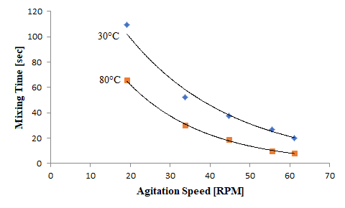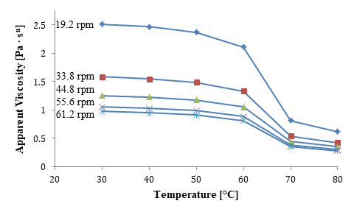

*Mixing time vs. mixing speed at 30°C and 80°C, apparent viscosity vs. temperature at different agitation speeds

* Mixing time of xanthan gum decreases as temperature and agitation speed increase
* The apparent viscosity of the solution decreases as temperature and agitation speed increase
* Agitation speed and temperature did not have a significant impact on power consumption

**Conclusions & Recommendations**

* Agitation speed and temperature should both be increased to decrease mixing time
  + Greater heat transfer coefficient, lower power consumption (less operation time)
* Agitation speed and temperature should both be increased to decrease apparent viscosity
  + Lower viscosity correlates with decreased mixing time, increased heat transfer coefficient, and lower power consumption due to decreased mixing time
* Operate agitated vessel at larger temperatures and agitation speeds for quickest throughput and homogenization of the 0.5% w/w xanthan gum solution